**Problem Definition:** *TO provide in-depth analysis of the activity being performed within the federated/non-federated application via scientific analysis of various short/long lived activities and benchmark the resource usage and the historical trend. This involves understanding the appliance activities initiated by resource manager and correlate with the existing performance benchmarking of the API/features*

*The project focuses mainly to come up with approach to monitor performance counter the various service within the application and analyze them to come up with recommendation to generate alert for degradation of performance based on the resource usage by the application.*

*The project comprise of the following component*

1. UI component
   1. To select specific service to monitor
   2. Allow selecting the performance counter and period to be monitored.
   3. Display performance matrix and its trend for certain period.
   4. Create graph to display the trend.
   5. Create Alert panel to display the alert.
   6. Create window to display the recommendation.

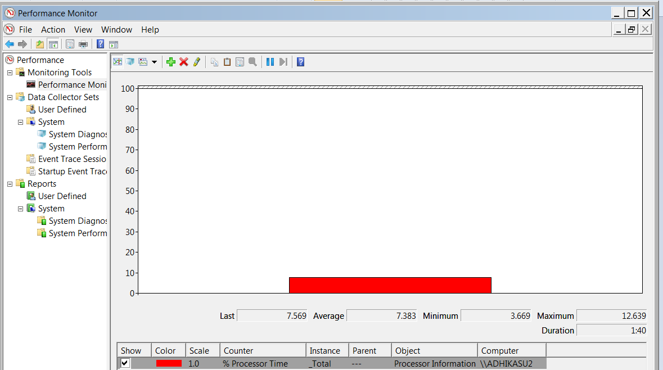

1. Middle tier
   1. Allow REST API to communicate to the system to pull data at any given point of time.
   2. Create java wrapper to interact with windows perfmon to collect counters
   3. Persist the information for historical issue.
   4. Create application knowledge base to recommend.
   5. Determine the threshold for the monitored application
2. Configure SQL express/mysql to persist the data.

Technology to be used:

1. JAVA
2. SQL Express
3. Application to be monitor is Eclipse
   1. Monitor eclipse process and bench mark its behavior.
   2. Load/Execute java program with extreme memory consumption/memory leaked on eclipse with

**Schematic component diagram: Performance monitoring of the application.**

